Agenda- To integrate Jfrog Artifactory with Pega. By this we would be saving our files all in the Repository unlike in Pega own repository.

Basically first go to JFrog and Sign Up and while choosing use the Cloud and Use Google for Sign Up

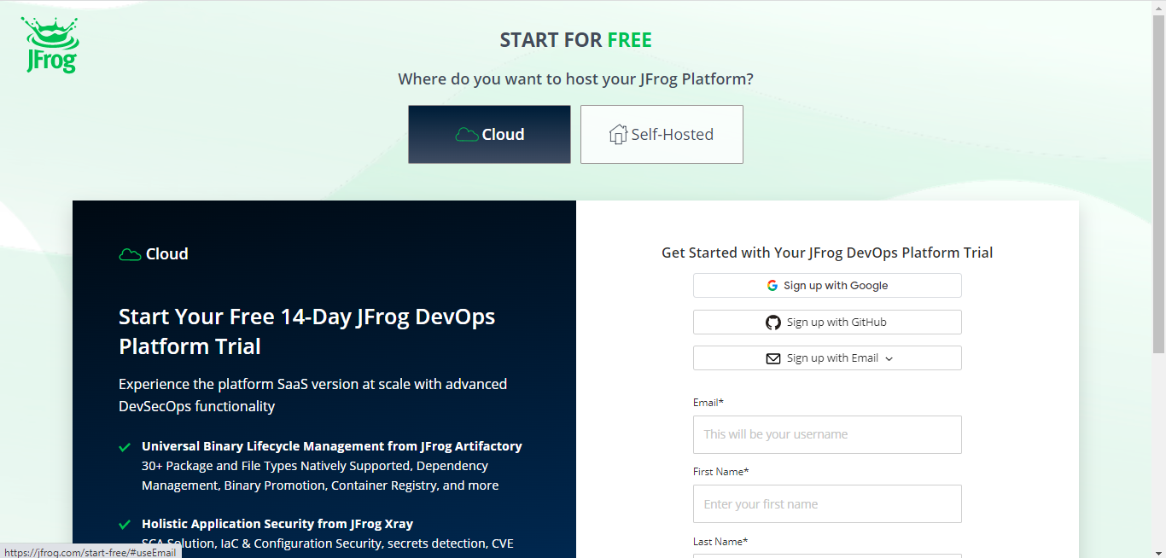

And then go for the Set Up of the Profile Platform Environment and then try give a name for the Environment and then give some dummy company Name and in the Hosting Preferences use the Google Cloud and in the Cloud Region anything and Click “Try It Out”

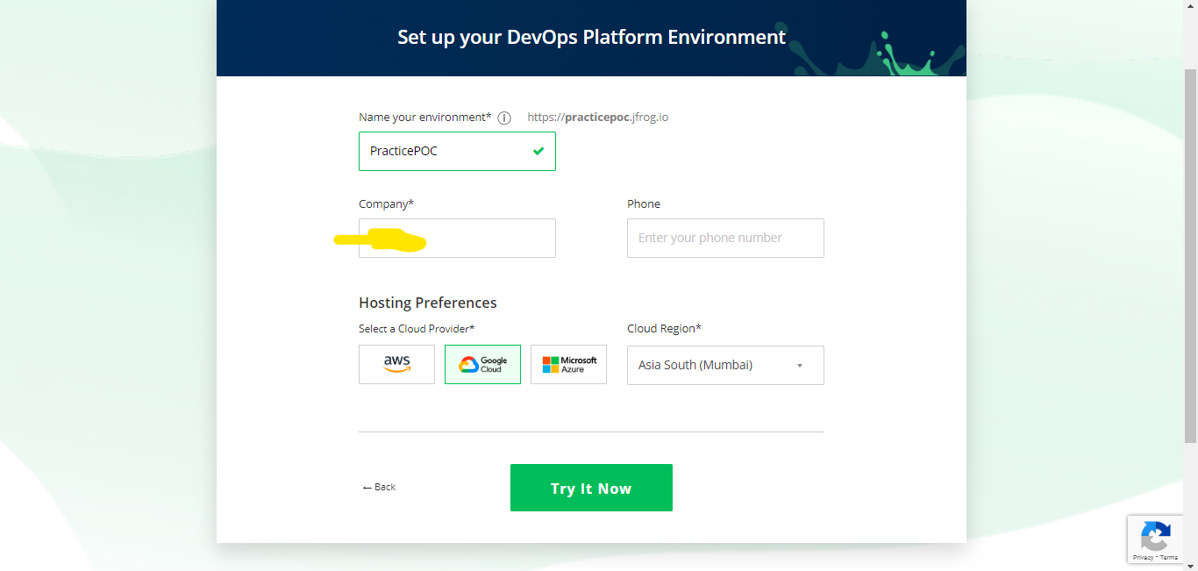

And then the below screen comes and let it complete.

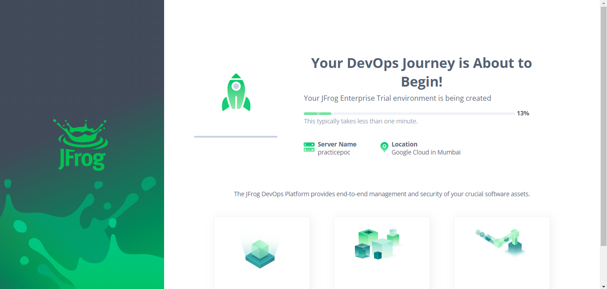



And after this we would be seeing the following screen 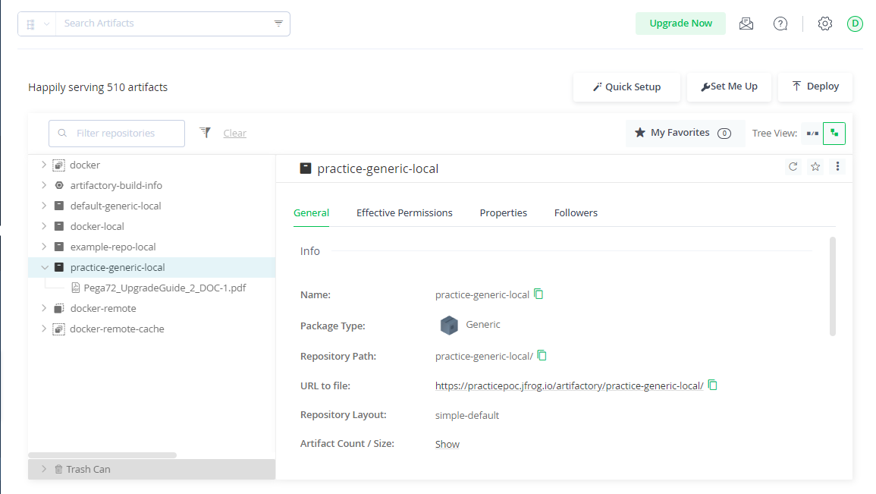

And then click artifacts on the left menu

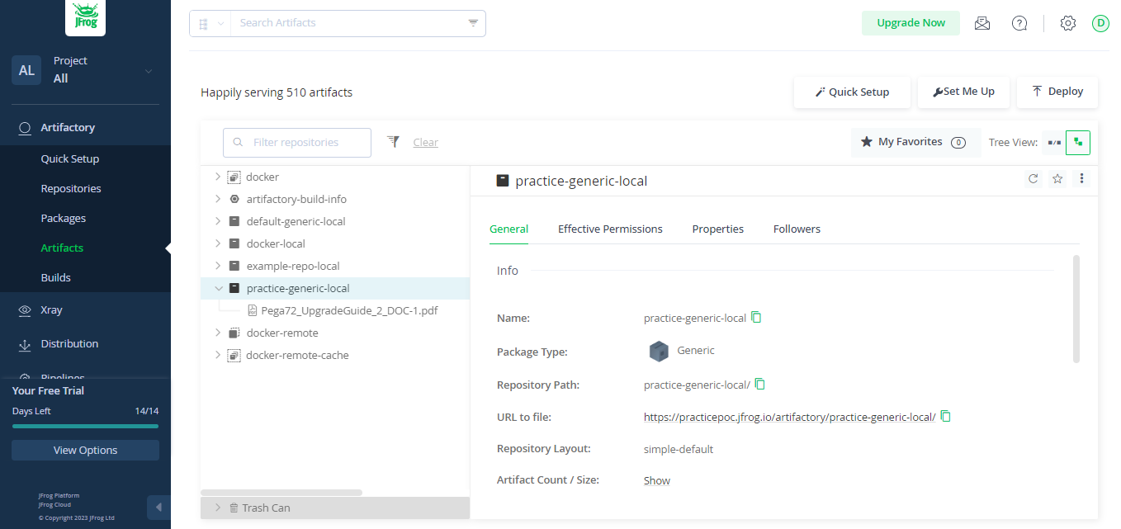

And in that we can create one new artefact or use the default one. I created new Artifact by clicking on Quick Setup and after that click Generic and create repositories and click create and now a pop up will come and close that and come back to Artifacts tab. You will see your created one..

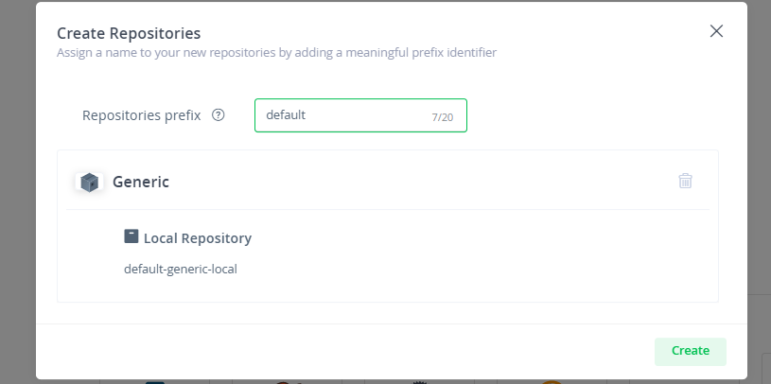

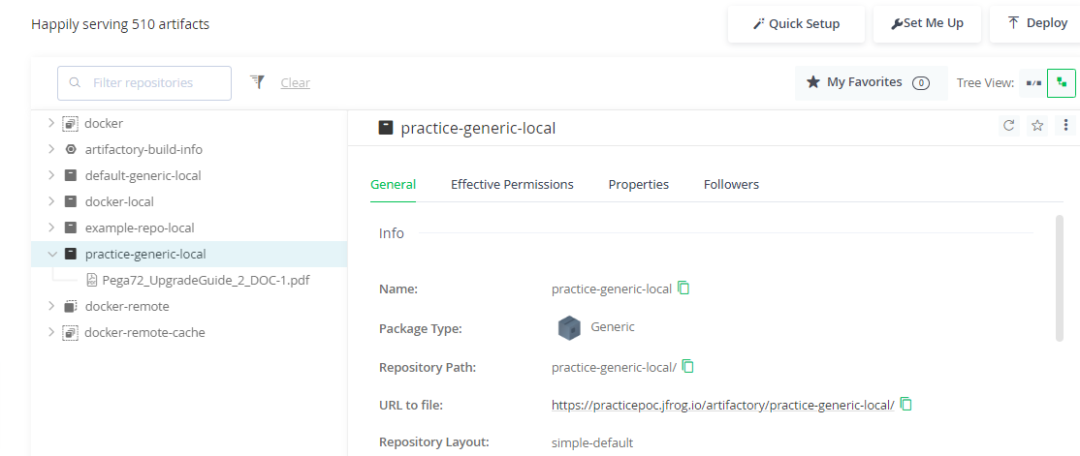

And here is the newly created one and then we can go for the Pega configurations and the JFROG Configuration is Complete.

In Pega in order to create or manage repositories we need to have the following access roles.

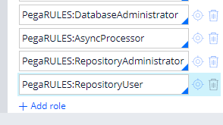

And after that create one case type so that you can add your files and documents.

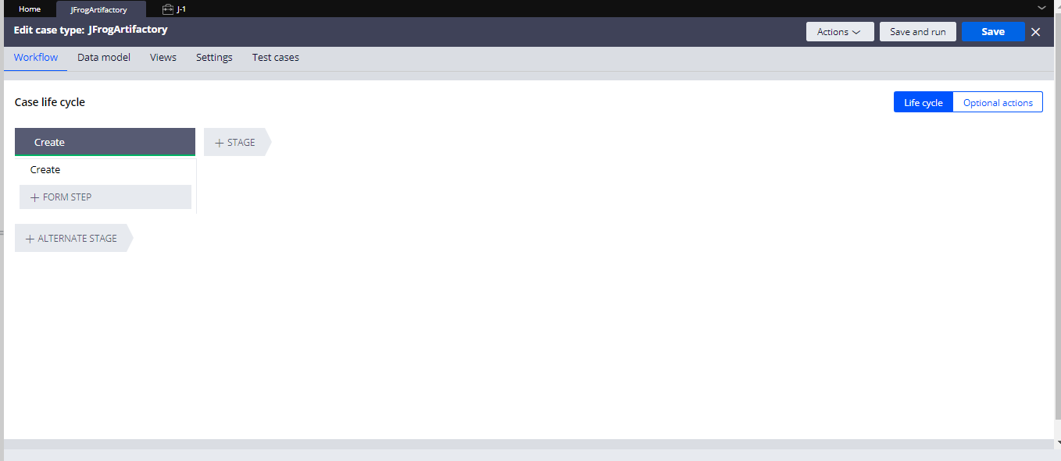

And then after that create repository from Sysadmin and then you would be asked for the host ID and repository

In the Host ID use the things that are before the artifactory <\*\*\*\*\*>artifactory<\*\*\*\*> and

In the repository name use the thing after the artifactory as given below in Image.

And then use Authentication Profile. Now use the Authentivcation Profile I created an authentication Profile and then go for the Username and password. They would be available while you created the account. And save the authentication profile and give the User ID and Password and save the rule and pass it in the repository rule

And if the Authentication profile is wrong then go again for the whole JFrog Configuration.

And now go for the Test Connection it should show Success as below

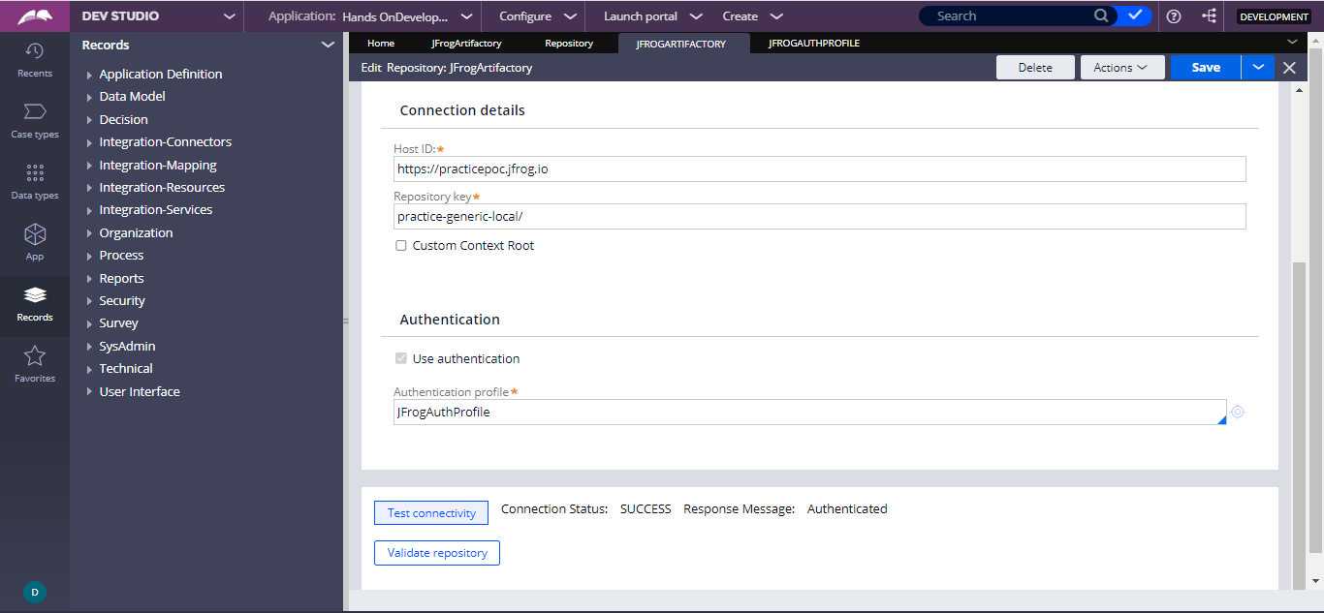

On click of Validate Repository you should get the success

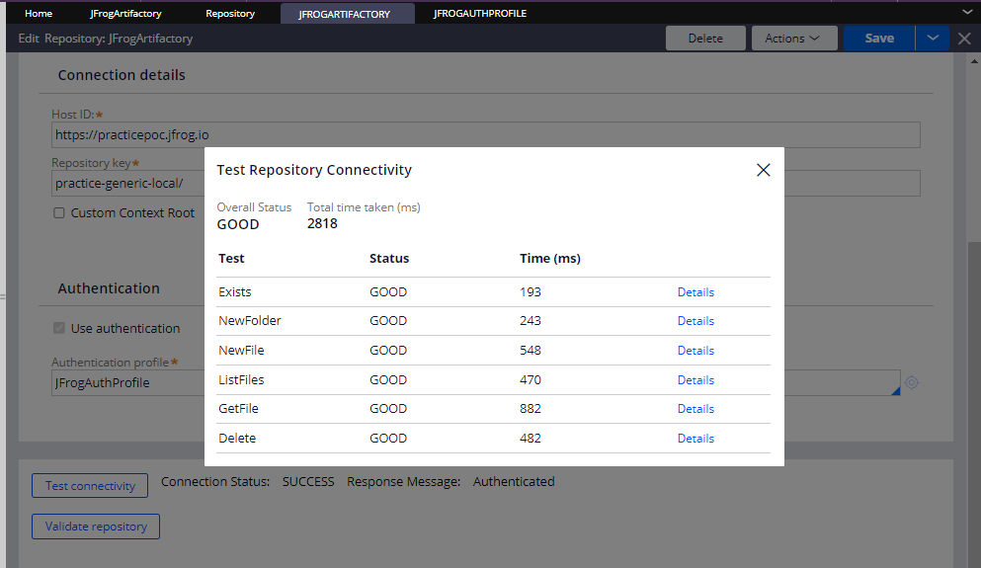

And after that go to the application definition and then go for the Integration tab and in the content management it is selected as the store in Pega Database and then store in the repository and then select the folder.

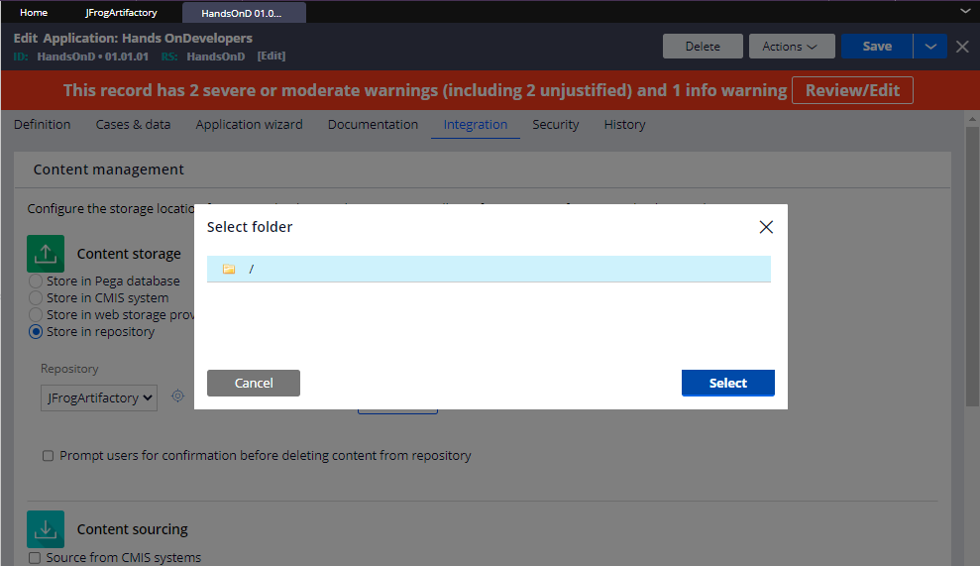

And configuration is done and after that we can double check if we have all the privileges and

then create a case and attach file and check In the repository.

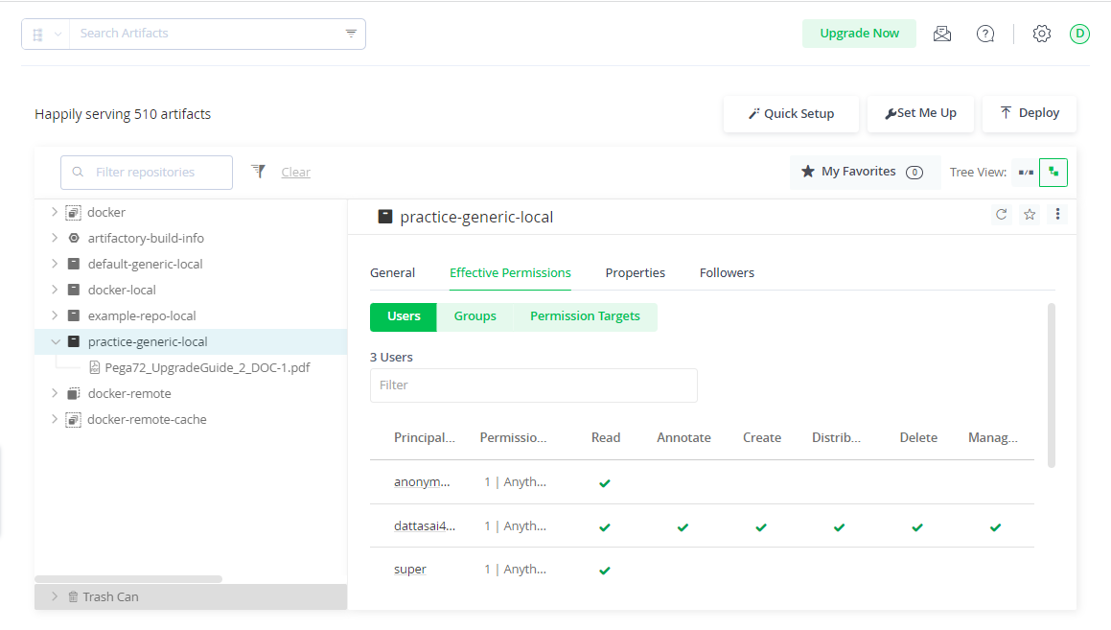



And checked privileges and then check the repository

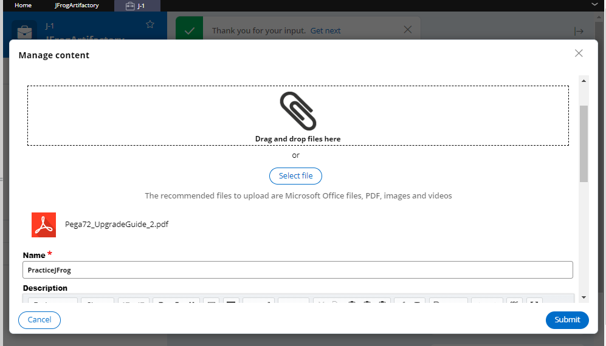

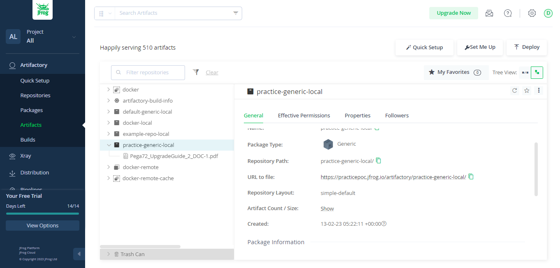

And then we can go for the JFrog Artifactory and then we can see as the document uploaded.